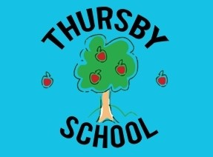
NEWSLETTER

February 2025
Dear Parents / Carers,
Firstly, I would like to thank you all for making my first half term at Thursby Primary School an extremely enjoyable one! The welcome from all parents, children and the wider community has been brilliant and I am thoroughly looking forward to the coming months here at Thursby.
I have been very impressed by the attitude towards learning and the behaviour of all the children at Thursby. I am very proud of the children and the staff for all their hard work this half term. The love for learning that is demonstrated on a daily basis here at Thursby is one to be admired and a testament to the hard work of all involved.
As always, this half term has been a busy one in school for all the children. We also have many exciting activities and events coming up in the coming weeks and months and we look forward to welcoming you all into school. Thank you to our wonderful PFA who have been busy organising upcoming events to support our school. The level of parental support and engagement here at Thursby is a real credit to the school. This helps us to maintain a happy, safe and caring environment that allows children to shine and develop.
The Book look is taking place on Wednesday 26th February from 3.30-4.15, in each classroom. This will be an opportunity for everyone to visit the class and enjoy looking at the books with the children.
Please enjoy reading all about the children’s learning from each class.
Next week is half term. I hope you all have a great half term week and we will welcome all children back to school on Monday 24th February.
As I have mentioned previously, please feel free to contact me directly if you require any support.
Thank you for your continued support,
Mr Barnes
Foundation Stage (Nursery/Reception)  Miss Butler and Mrs Gibson  All our Nursery and Reception children have embraced 2025 with enthusiasm, curiosity and some amazing learning! Our new starters from January 2025 have all settled in really well and have become part of our early years’ family.  Over the past few weeks, our children have immersed themselves in some brilliant stories about our Heroes and People who help us. They have continued with their daily phonics and number activities. In addition, to their Reading books shared in school and at home, our Reception children are beginning to create and build simple sentences to enhance their reading, spelling and writing.  The children have enjoyed their Fencing sessions with Mr Armstrong learning new disciplined skills about Fencing moves and combat. In Spring 2, they will be learning Archery skills.  In these final weeks we are celebrating Chinese Lunar New Year with a Snake theme and sampling different foods, Mental Health Week with a Dress to Express day and Valentines’ day.  In Spring 2 term, we will be exploring Weather stories, celebrating World Book Day, creating exciting cards and crafts for Mothers’ Day and Easter.  We would like to wish you all a happy and safe half term.  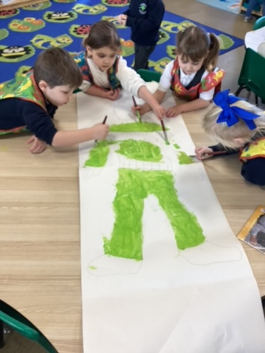  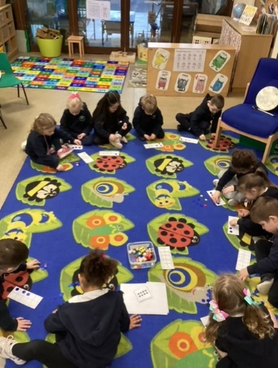  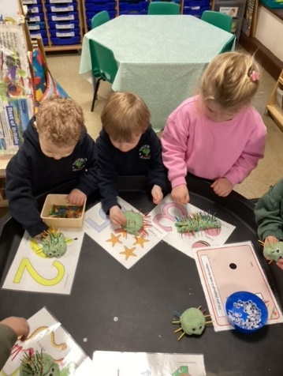 | Class 2 (Years 1 & 2)  Mrs Milburn & Miss Gregson  The children in Class 2 have made tremendous progress and are continuing on their journey as independent learners.  Our focal point this term has been our study of castles. The children have thoroughly enjoyed learning about their history, architecture, and the roles of the people who worked in them. We had an enjoyable day at Lowther Castle which included a visit to the adventure castle playground.  Throughout the term, we have been placing a strong emphasis on oracy, encouraging the children to articulate their thoughts and ideas effectively. In our History lessons, we have explored the methods of siege warfare and even constructed our own trebuchet catapults.  Our PE sessions have introduced the children to the art of fencing, where they have learned to adopt the alert and watchful stance of 'en garde.'  As budding artists, the children have delved into colour theory, experimenting with primary colours to create various tints and shades of secondary colours. The class has produced some stunning artwork that they are eager to share with you.  In Literacy, we have embarked on a creative journey to write ‘fear’ stories inspired by Julie Fagliano's book, 'A House That Once Was.'.  In Mathematics, we have been consolidating our understanding of addition, subtraction, and multiplication. The children have enjoyed counting in multiples of 10, 5, 3, and 2, laying a strong foundation for the introduction of times tables in the coming term.  Looking ahead, our next topic will be 'Traditional Tales,' our Science lessons will focus on 'Materials,' in Geography, we will investigate the human and physical geography of our local area.  We are also looking forward to welcoming a student teacher – Miss Brown who will remain with us until June.  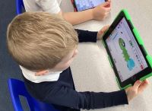  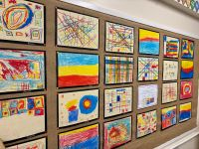
Class 3 (Years 3 & 4)  Mrs Brown & Miss Gregson  A great start to 2025 from Class 3, well done everyone!  The children have been working hard in maths, learning about area and multiplication and division. In English, they have written some excellent losing tales. Our class text has been 'Sam Wu is NOT afraid of ghosts'. We have really enjoyed reading the text, exploring new vocabulary and improving our inference skills.  The children have all improved their swimming and fencing skills in PE. In Art, the children have been learning about prehistoric painting. They have used charcoal to recreate the style of cave artists and have demonstrated a good understanding of colour mixing with natural pigments. Their final pieces were excellent!  In Science, the children have started their learning about plants. They carried out an investigation to see whether the amount of light had an effect on plant growth. In History, the children have enjoyed learning about the development of the railways and why they are a significant part of history.  Next half term, the children will develop their fieldwork and mapping skills in Geography - you might see us around the village exploring. In Science, the children will continue their learning about plants and will investigate the way in which water is transported.  In Design & Technology, the children will be making Earthquake resistant pavilions. Within the unit, the children will have opportunities to design, make, test and evaluate. Our class text will be 'Armistice Runner' by Tom Palmer.  Swimming will continue on a Monday afternoon next half term. Class 3 will continue to work with Mr Armstrong on a Thursday next half term with a focus on archery.  We are really looking forward to another busy half term filled with lots of new learning.  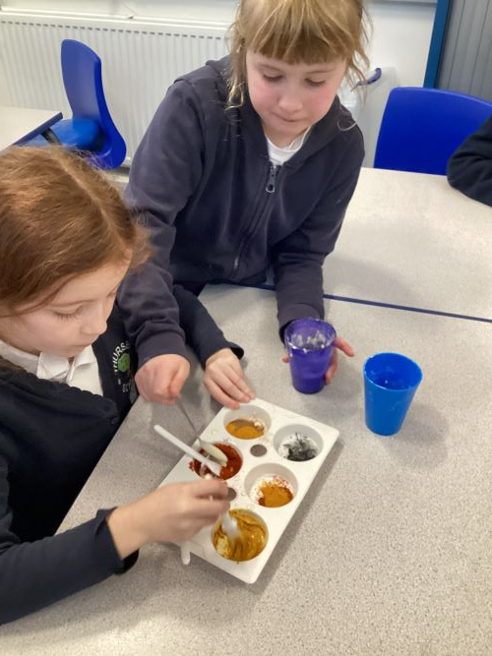  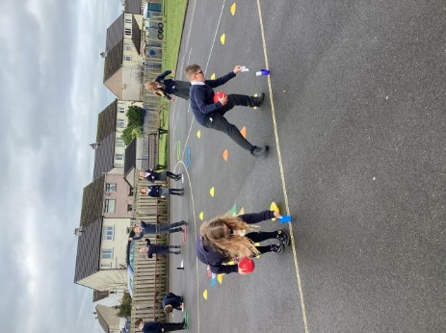 | Class 4 (Years 5 & 6)  Mr Colombi  Class 4 have had another fantastic half term, working extremely hard and having an excellent attitude towards there learning.  In Science, we have learnt about ‘Light’ and how we see things, how objects reflect light, how colours are seen and how objects can look differently in water. They have been really interested and engaged on how light works; it has been great to see their inquisitiveness.  In History, we have studied the Ancient Mayan Civilisation. We learnt that these people came from Mesoamerica and lived over 1500 years ago. They were excellent architects and built some amazing temples. They were also well-known for their agriculture and were amongst the first to grow: chillies, corn and cacao beans.  In Computing, we have focussed on Video Editing. We watched DanTDM and saw how the camera recorded him using different techniques, for example, pan, zoom, long shot, close up and over the shoulder. We are using these techniques for our own videos.  Next half term, we will be learning about comparing people and places, living things and their habitats, web page creation, mechanical systems, exploring musical notation and the Easter story.  We will hopefully be visited by NISCU to enhance the RE unit or work on Christianity.  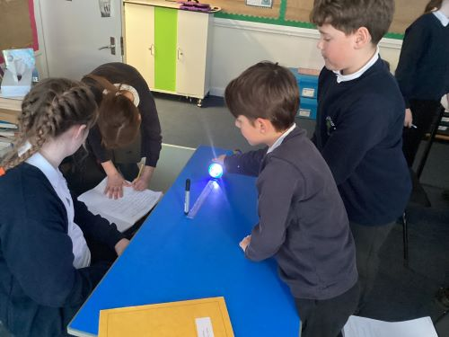  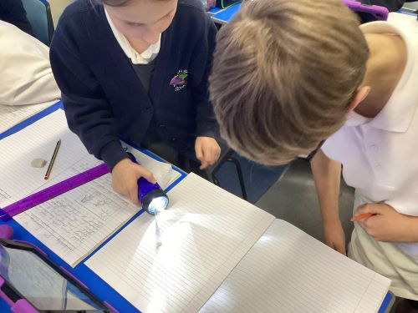
Upcoming dates
Friday 14th February – End of half term – normal finishing time
Monday 24th February – Child back to school
Monday 24th February – Road Safety Workshop- Class 2
Wednesday 26th February 3.30-4.15 Book Look in all classes
Wednesday 5th March – PSCO Assembly re internet safety
Thursday 6th March – World Book Day
Friday 7th March – Class 3 to Stockswood
Tuesday 11th March – Fire Service to visit Class 1
Friday 14th March – Class 3 Drumming with ZoZo
Monday 24th March – Puppet Performance for Class 3 & 4
Tuesday 25th March – Reception children hearing tests
Weeks commencing 19th & 26th March – Parents Evenings – further details to follow
Thursday 27th March – PFA Pop Up Mother’s Day Shop
Friday 4th April – End of Spring Term Early Finish 2pm

Attendance
Congratulations to Class 4 who have the highest attendance during the Spring 1 half term (up to and including 7 February), 96.77 %

House Points
There will be a non-uniform day for ASH (Red) house on Friday 28th February, as they have gained the most house points this half term.

School Lunches

We have been advised by our School Meals Provider, Dolce, that the cost of meals will increase from April 2025

This will mean that Nursery children’s meals will cost £2.64 per day and pupil meals will cost £3.16 per day.

