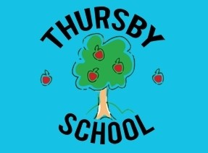
NEWSLETTER

December 2024
As we approach the end of another half term and also the end of the year 2024, thank you to everyone for all you do for Thursby School.
Thank you to our PFA group, they have recently organised Chocolate Bingo and the up coming Christmas Fayre, this has enabled them to provide a £5 donation, per child, towards the Christmas Trips to Aztec Soft Play, Keswick and Vue Cinema.
This is the last welcome part of Thursby’s school newsletter I will be part of and as the term is coming towards an end it is with the greatest pleasure to add my own section in for the last time.

Autumn term has certainly been different, mostly due to the changes ahead in my career. I have tried hard to try and just enjoy the moments, small and big, amongst a challenging term of juggling many roles but what always makes me smile are the little chats with individual children, seeing their smiling faces and also seeing how proud they each are of their new learning. This will all be a huge miss to me though I will remember it all with gratitude.

I will be sending my own letter out to you all as the term ends so for now we keep moving forwards and start enjoying the wonderful Christmas time ahead in school and at home. The lead up to Christmas will be full of magical moments for our children and a very special time in school.

There is always so much to celebrate in school, from learning in the class room, participating in events and competitions with other schools, having visitors in school and going on school visits. There is always a hive of activity.

Mrs Williams

Please remember school closes at 2pm on Friday 20th December and re-opens as normal with Breakfast club at 8am on Tuesday 7th January 2025.


Finally, as a staff team, we wish you all a very Merry family Christmas and a Peaceful New Year.

This Photo by Unknown Author is licensed under CC BY-SA

Foundation Stage  Miss Butler and Mrs Gibson  The children have enjoyed their first term in school. They have been very busy on their learning journey – daily phonics, reading and maths sessions and learning through play.  We have enjoyed being in Fantasy land, reading our focus books, doing different activities within our setting including drama, creating displays and craft.  The children are working hard learning their songs and parts in the production of The BIG little Nativity – we cannot wait to share this with you!  We are looking forward to our Aztec Soft play trip complete with surprise visit from Santa, Christmas party and lunch to finish off an eventful half term.  In Spring 1 2025, our first topic will be about Heroes – People who help us, real-life heroes, occupations and fictional superheroes. There will be some exciting learning experiences including some visits from real-life heroes.  In Spring 2, we look forward to our annual visit to Stocks Wood Education Centre at Rosley for a day of woodland adventure. Details to follow at a late date!  We would like to wish you all a happy and peaceful Christmas and New Year.  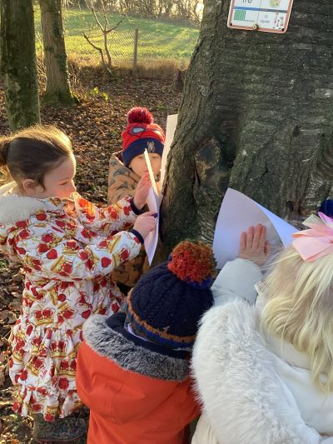  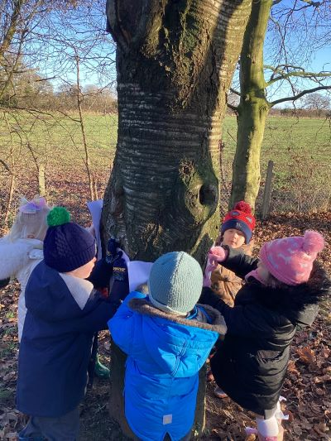  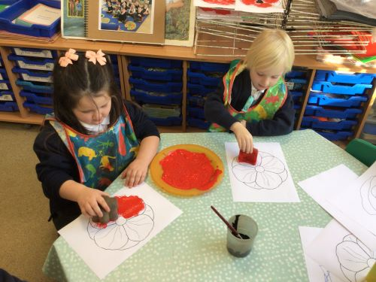 | Class 2  Mrs Milburn & Miss Gregson  What a wonderful half term we’ve had in Class 2! The children have worked so hard, and it has been a joy to see them grow and flourish in their learning. Each and every one of them has made fantastic progress, and they should all feel incredibly proud of themselves.  As artists, we got creative with fabrics, using plaiting, knotting, and threading techniques to produce a stunning woven art piece that brightens up our classroom. In geography, we explored maps and atlases, focusing on the human and physical geography around our school. The children even became cartographers, creating maps of our classroom!  In English, we dived into the squelchy, slimy world of The Disgusting Sandwich by Gareth Edwards, which inspired the children to write some wonderfully descriptive stories. We also put our instructional writing skills to the test by making and writing recipes for some deliciously yummy chocolate crispy cakes.  In science, we’ve been learning all about humans, thinking like real scientists by asking big questions like, “Is the oldest person always the tallest?” The children have loved investigating and sharing their findings.  In Design & Technology, the children have been developing their food preparation skills such as cutting, spreading, grating and snipping. They have designed a healthy breakfast which they will make and evaluate.  A special upcoming highlight is our trip to Theatre by the Lake to see Tinsel, which we’re all very excited about—it promises to be a magical experience to round off the term.  Looking ahead to next half term, we’ll be learning about homes and castles, exploring materials and their uses in science, and delving into colour theory in art with a focus on the work of Romare Bearden. There’s so much to look forward to, and we can’t wait to continue the learning journey together.  Thank you, as always, for your ongoing support—it makes such a difference to everything we do. Wishing you all a restful and happy holiday, and we look forward to seeing everyone back refreshed and ready for another exciting term.  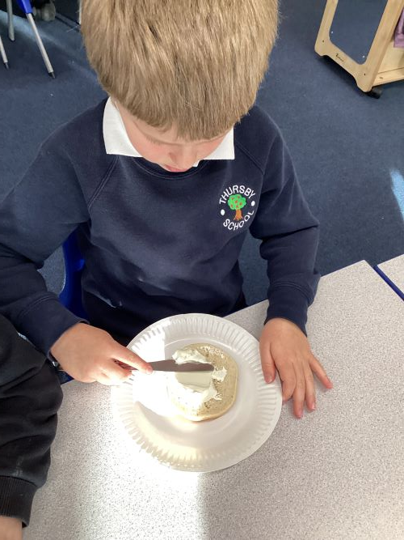  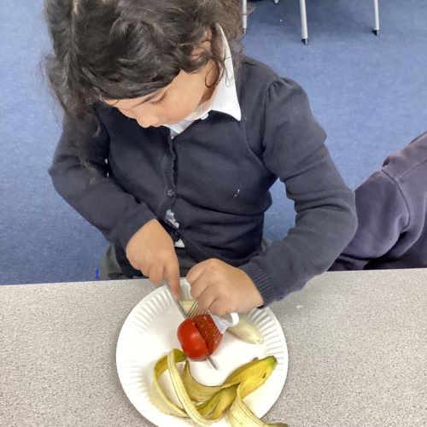  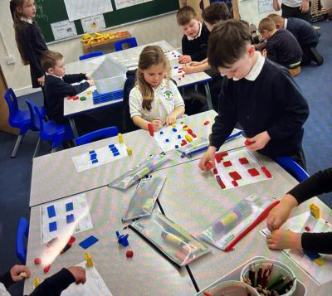
Class 3  Mrs Brown & Miss Gregson  Class 3 have had another brilliant half term, well done everyone!  The children have been working hard in maths, learning about addition and subtraction as well as multiplication and division. In English, they have written some excellent warning tales and newspaper reports too. Our class  text has been 'The Iron Man'. We have really enjoyed reading the text, exploring new vocabulary and improving our inference skills.  The children have all improved their hockey and dance skills in PE. There have been some excellent torches designed in Design and Technology which include an electrical system. In science, we have been learning about electricity.  In Geography, the children have learnt about the regions, counties and cities of the UK.  Next half term, the children will be studying the history of the railways as part of their history work. In Science, the children will be learning all about plants - they will investigate the way in which water is transported within plants and also look at the functions of different parts of flowering plants. As part of their PE learning, the children will be doing gymnastics and will have weekly swimming lessons on a Monday afternoon.  Mrs Brown and Miss Gregson are thrilled with how hard the children have worked this term and hope they have a fun-filled Christmas break!  Merry Christmas Class 3.  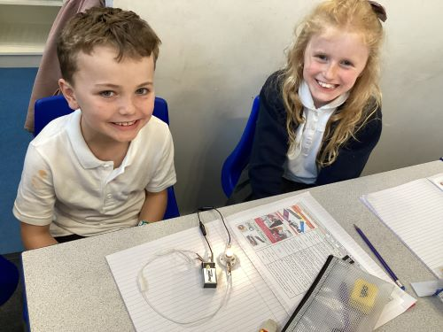  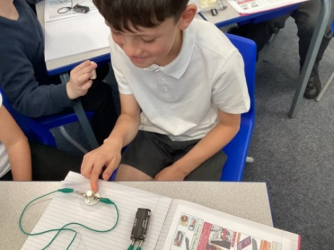 | Class 4  Mr Colombi  Class 4 have been fantastic with their learning this half term showing excellent effort in concentration, listening and attitude to learning.  In Geography, we have learnt about Mountains, Earthquakes and Volcanoes. We studied the layers of the earth, tectonic plates, what causes earthquakes and how mountains and volcanoes are made.  In Science, Electricity has continued to be our focus with an emphasis on investigational aspect. We have linked this learning in Design and Technology where the children have created their own ‘steady hand game’ using their circuit knowledge.  In Computing, the children have learnt about variables and how changing these can affect how a game works, making it easier or harder.  It was also our residential to Robinwood in which the children had a fantastic time (me too!). They have learnt some valuable life skills and had great fun on the activities.  Next half term, we will be learning about the Ancient Maya civilisation. The Maya civilisation of the Mesoamerican people is known by its ancient temples. Other units of work next half term include: Video Editing, French Food and Mechanical Systems.  I hope you all have a lovely and peaceful Christmas!  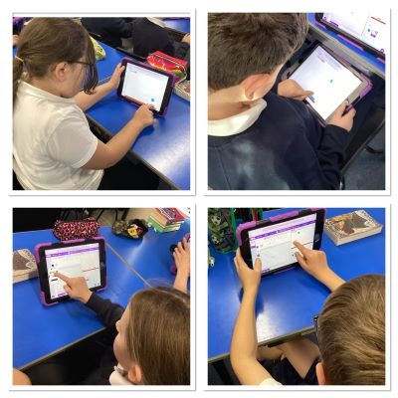
Christmas Crafts After School Club

Reception, year 1 and year 2 have enjoyed the festive craft club afterschool this half-term. They have been making lots of Christmas decorations and have had great fun! Take a look at some of the pictures.
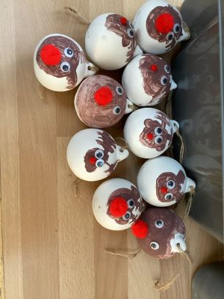
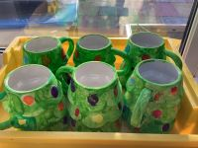

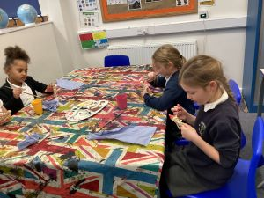

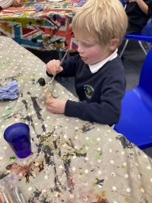

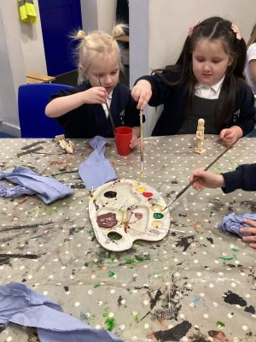
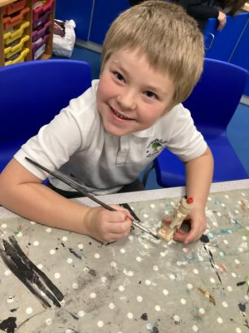

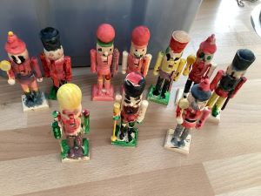
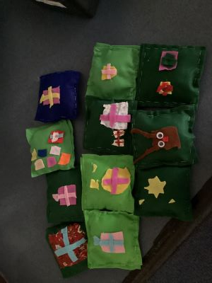

Christmas Plays & Carol Service

Class 1 & class 2 will perform their Big Little Nativity on Wednesday 11th December at 1.45pm. Due to insurance restrictions, the entry to this is by ticket only, these are free and available from the office, now.

Initially each child will be allowed 2 tickets from now until Friday 6th December, however after this date any left over tickets will be issued on a first come first served basis.

After the performance the children will be allowed to leave slightly earlier to go home and older siblings can be collected too.

Class 3 & 4 will be taking part in a Carol Service in St Andrew’s Church on Monday 16th December at 2pm, everyone is welcome to attend the Church. After the service, children will be allowed to go home, younger siblings can be collected from school too.

Attendance

Congratulations to Class 2 who have the highest attendance during the Autumn 2 half term (up to and including 29 November), 96.08 %

House Points

There will be a non-uniform day for ASH house on Friday 10th January as they have gained the most house points, up to Friday 29th November.

REMAINING DATES BEFORE END OF TERM
Monday 2nd December Parents Evenings Week
Thursday 5th December NISCU Puppets to visit Class 1 & 2
PFA CHRISTMAS FAYRE THURSBY VILLAGE HALL 4.30 PM
Monday 9th December Cycle Training Year 5 (most days for the week)
Last Day For Deposit London Residential (current year 4 & 5 children)
Tuesday 10th December Cinema Trip KS2
Wednesday 11th December 1.45 pm Class 1 & 2 Christmas Production
Friday 13th December Class 2 Theatre By the Lake Visit
Monday 16th December Christmas Church Service in St Andrews 2pm for KS2 & Parents
Tuesday 17th December Class 1 to Aztec Soft Play
Tuesday 17th December Class 3 & 4 Christmas Party PARTY CLOTHES MAY BE WORN
Wednesday 18th December Class 1 & 2 Christmas Party PARTY CLOTHES MAY BE WORN
Thursday 19th December Christmas Dinner – CHRISTMAS JUMPER DAY
Friday 20th December 2pm End Of Term
Tuesday 7th January 2025 Children Return To School
Merry Christmas from everyone at Thursby School

